VCS TASK
Establish a new directory, populate it with script files, initiate an empty repository on GitHub, convert the local directory into a Git repository, and link it to GitHub for pushing the code into the repository.Perform merge, rebase, stash commands in following github repo.

. Creating a Folder
. Cd to the Folder
. Open it on VS Code

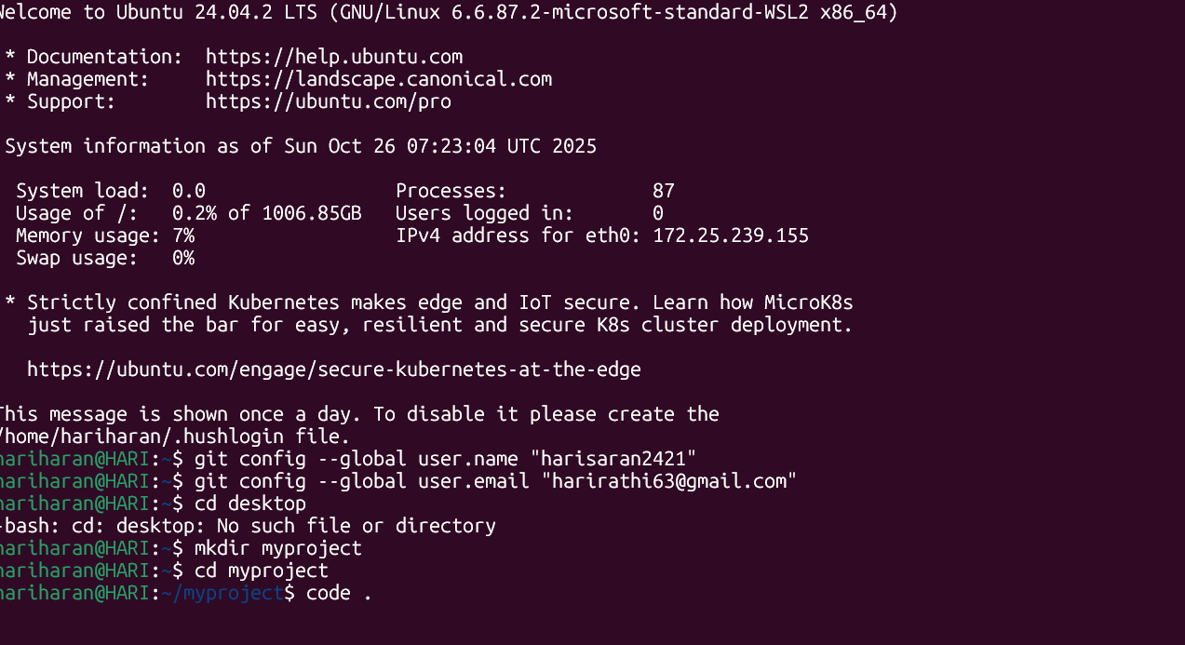

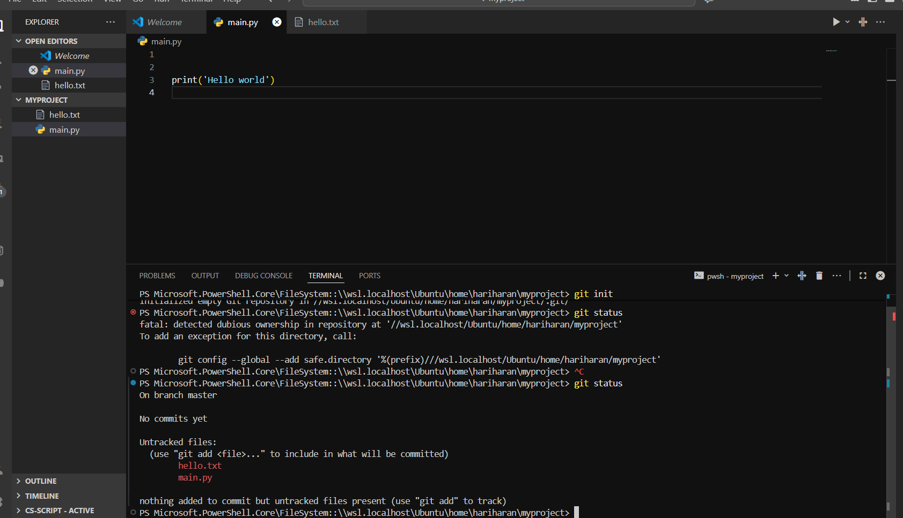
. Creating a simple python program and text folder
. Git init
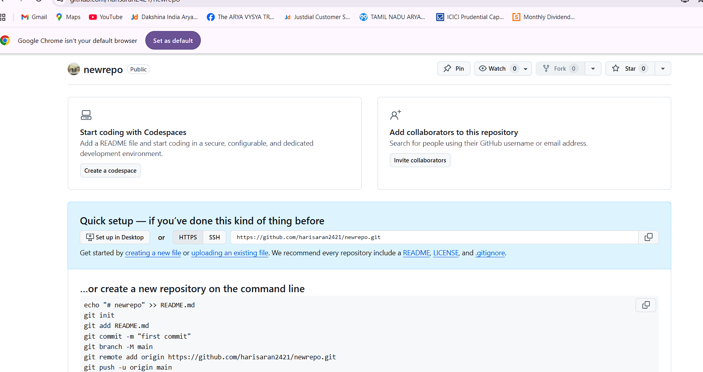
. Creating a new Repository in github

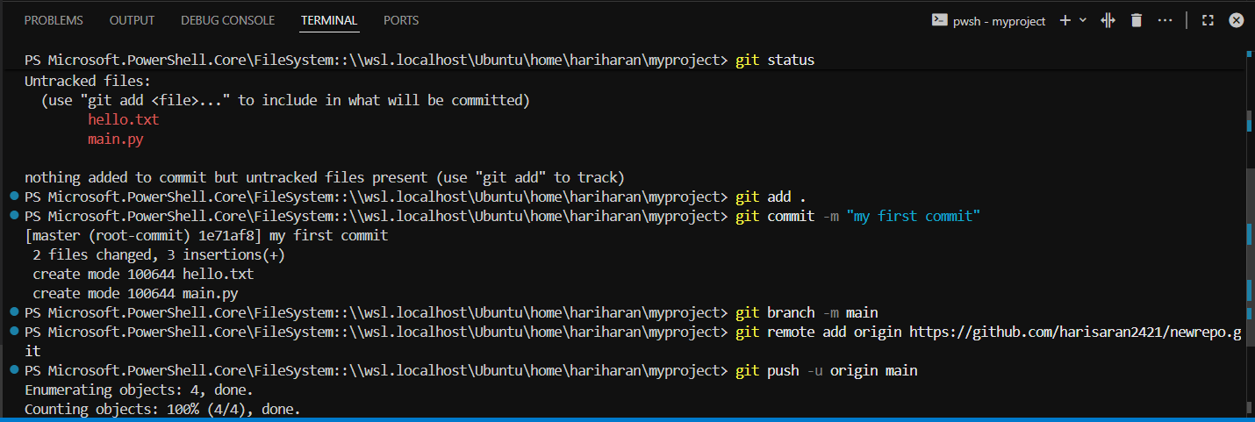
. Git add .
. Git commit -m “My first Commit”
. Git Branch -m main
. Git Remote add origin https://github.com/harisaran2421/newrepo.git
. Git push – u orgin main

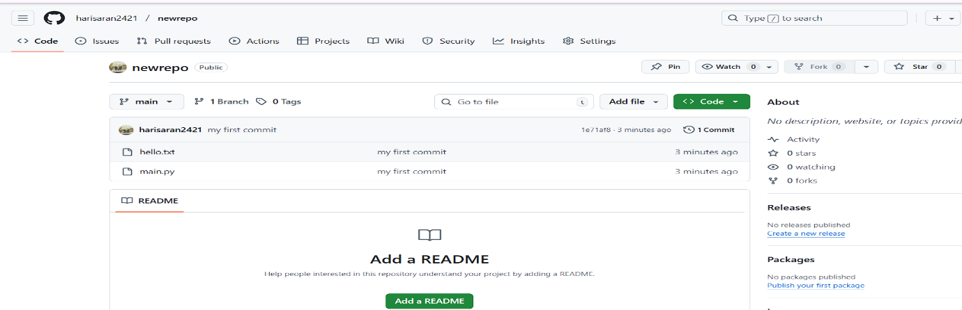
. Refresh git repository then Push files are showing

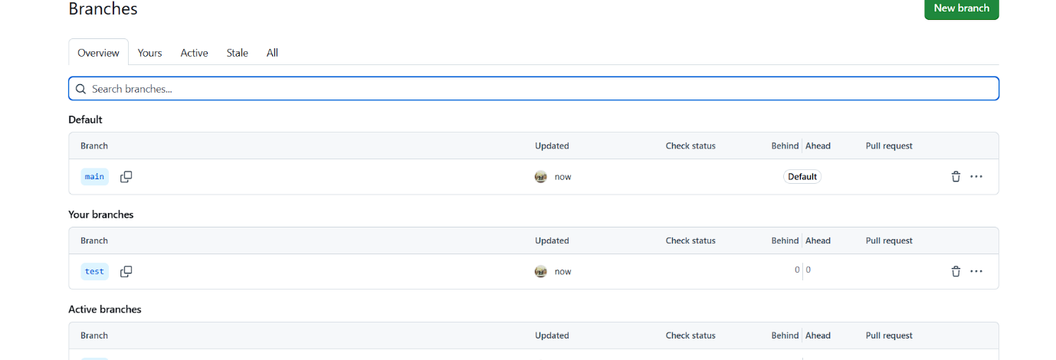
. Creating a New Branch name Test

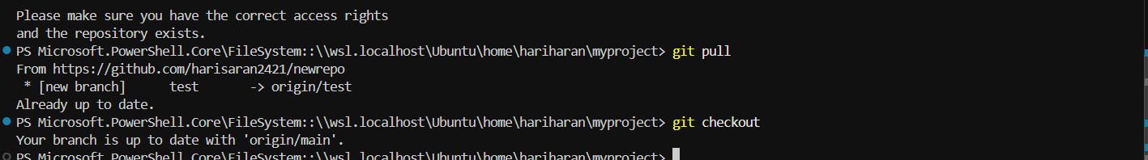
. Git pull
. Git checkout to view all branches

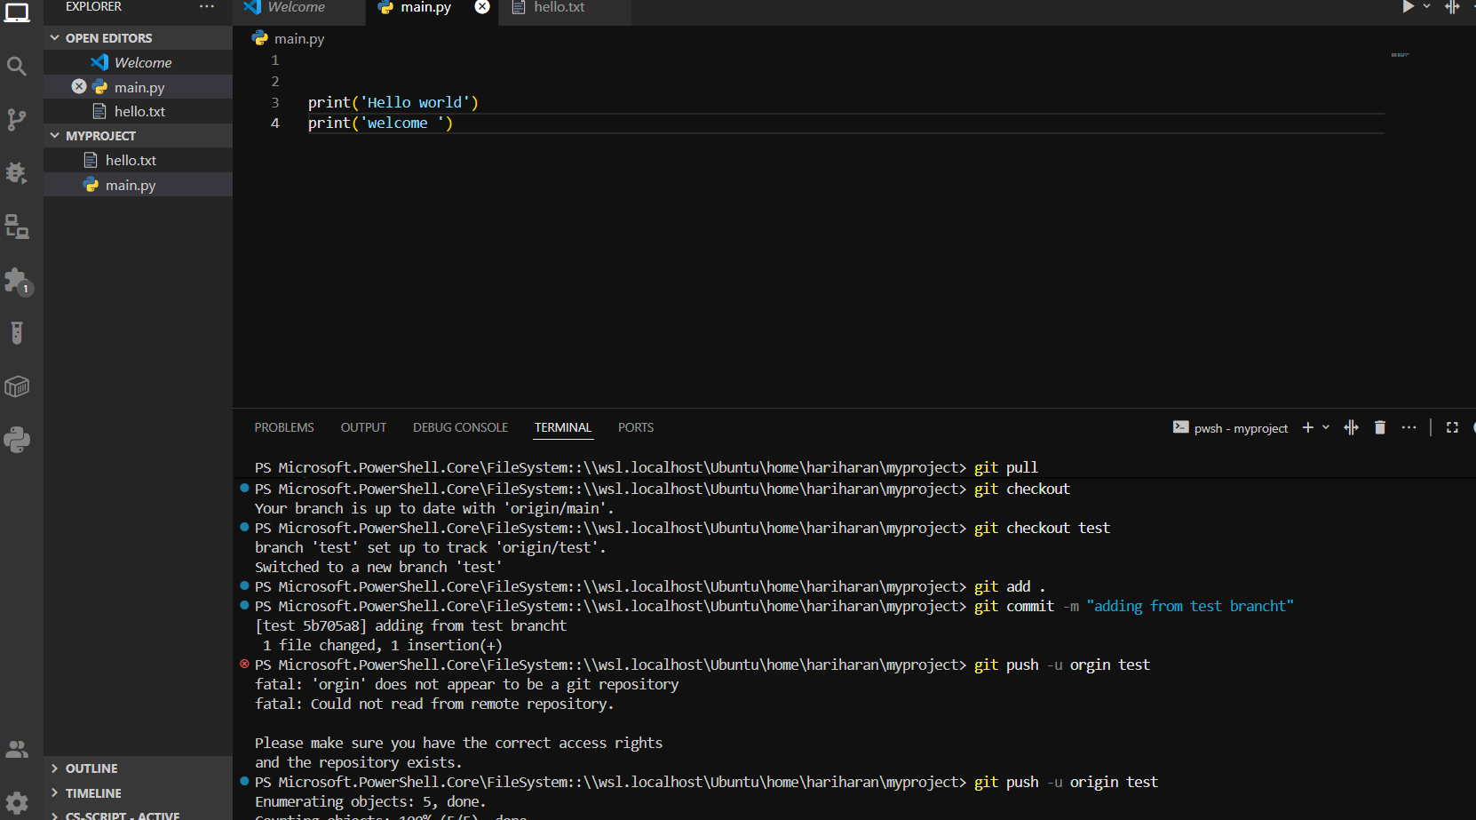
. Edit the python file
.Switch the branch to test
. Git add
. Git commit -m “adding from test branch”
. Git push
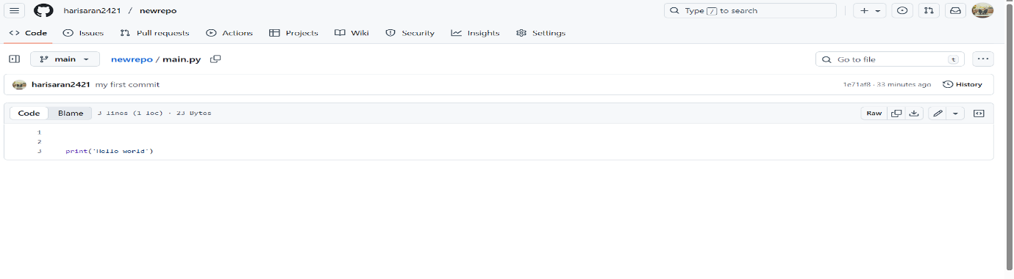
. Main branch print (“hello world”)

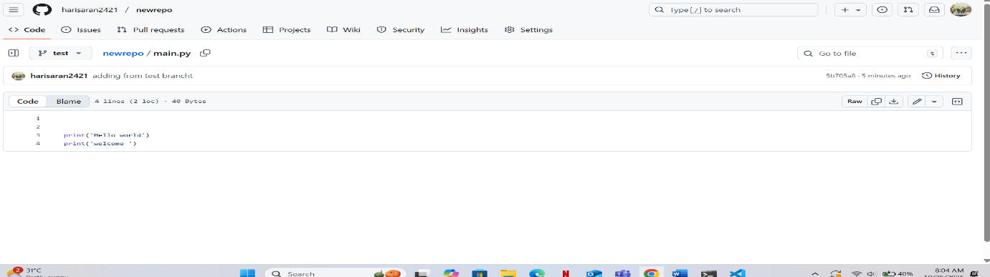
Test branch
Print (“Hello World”)
Print (“Welcome”)
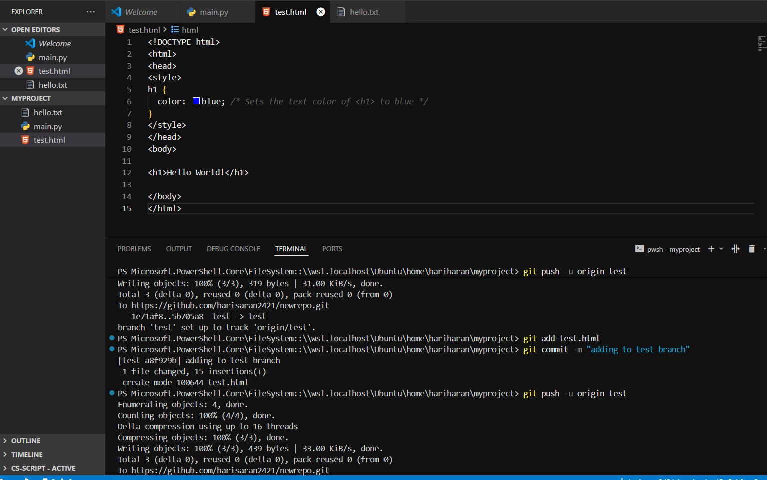
. Adding a new html file to the test branch
. Git add test.html
. Git commit- m “adding file to the test Branch”
. Git push – u origin test
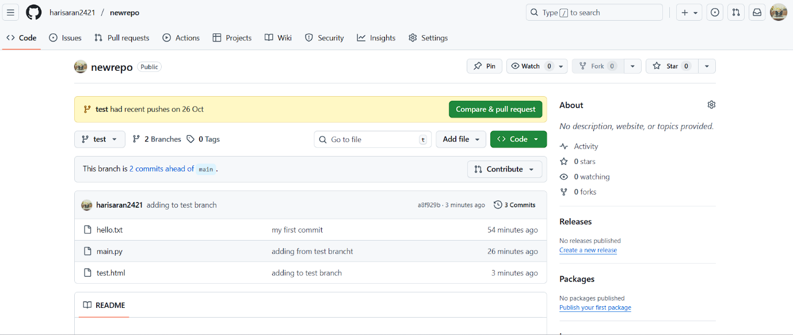

.Html file showing on the test Branch

Git Stash

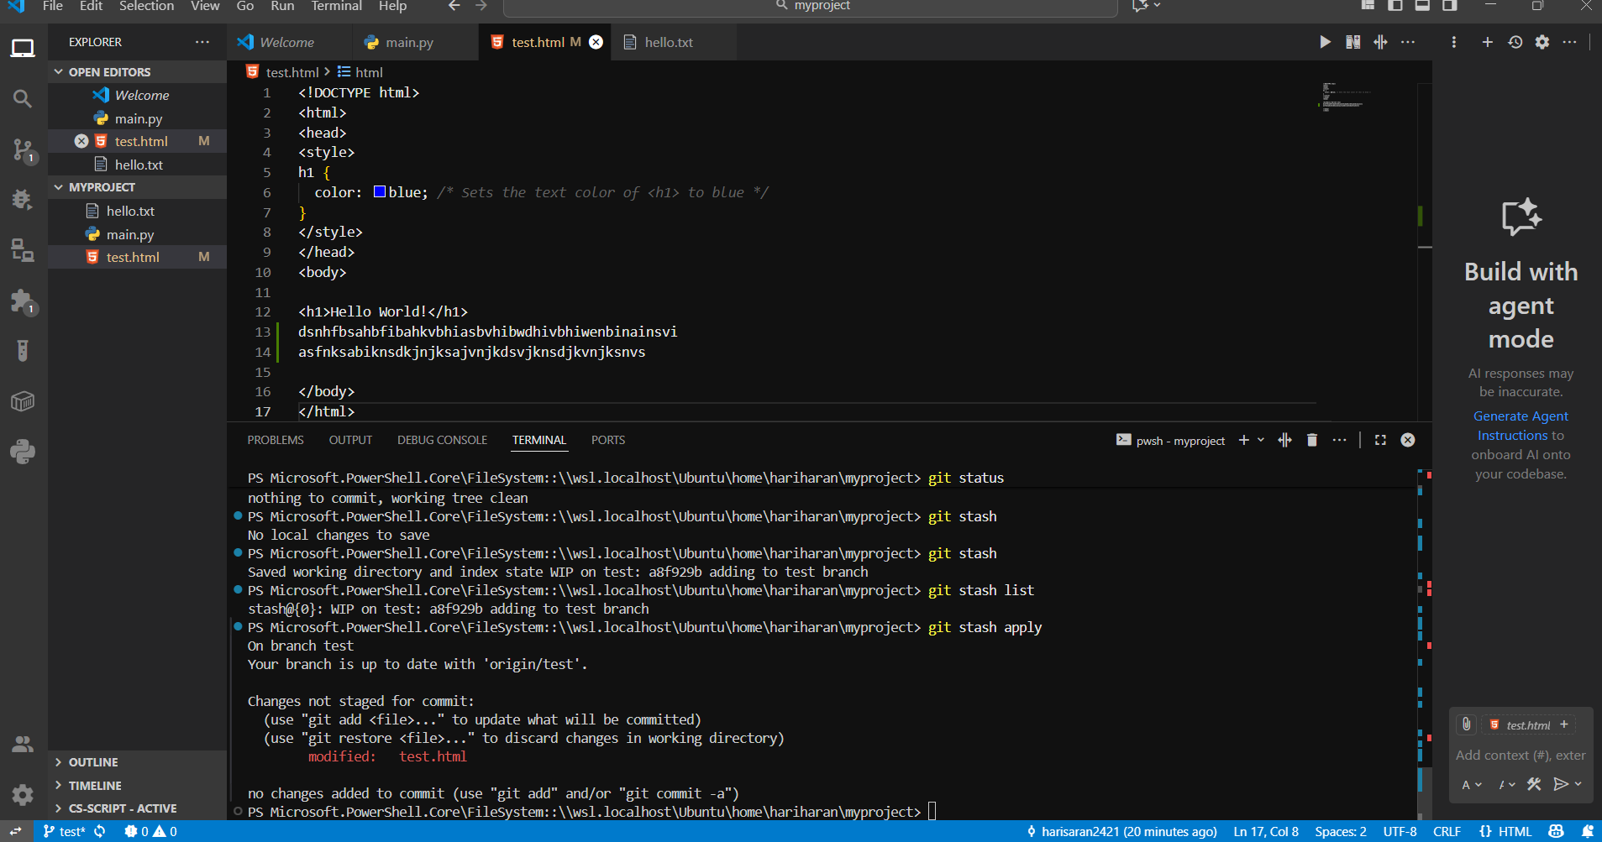

. adding some files in html file
. Git stash take a copy of file
. Git stash List to view a stash files
. Git stash apply to apply the changes

Git Rebase
